Instructions: Read the text below and answer the questions. You have 7 minutes.
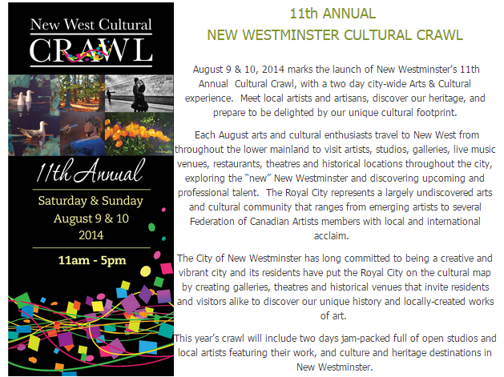
- What is the purpose of this text?
  - It is an announcement about a community event.
  - It is a review of a community event.
  - It is a proposal for a new community event.
- Where might you find this text?
________________________________________________________________

- Who is the intended audience for this text? (circle all that apply)
  - Artists and art enthusiasts.
  - People who live on Vancouver Island.
  - All members of the community.
  - Families with children.
  - Families without children.
- Why is this event held in the summer?
____________________________________________________________________
- What is the writer’s tone?
  - Excited, but somewhat formal.
  - Happy and very casual.
  - Distant and cold.
- If after reading this text, you decided that you wanted to attend the event, what information would you need? How would you find that information?
______________________________________________________________________
______________________________________________________________________

- Would you want to attend this event? Why or why not?

______________________________________________________________________

